Warning Blackspot Index: Bushfire Risk and Warning Reachability Across 765 Northern Territory Communities
CDU IT Code Fair 2026 | Data Innovation Challenge | Theme: Remote Connectivity
Team 10: Last Bar
Registration ID: DIC010
Member | Role | Student ID
Van Hoi (Hendrick) Dang | Data pipeline, index design, report | S395598
Le Nhat Minh (Thomas) Tran | Data collection, analysis, visualisation | S390789
Minh Hoang Bui | Offline prototype application | S399292
Ngoc Ngan (Kelly) Le | Slide deck, design, ethics section | S401010
Submitted 30 September 2026
Repository: https://github.com/HendrickDang/nt-warning-blackspot-index

Summary
Remote Northern Territory communities face bushfire risk and limited mobile coverage at the same time, yet the two are usually assessed separately. This report asks one question of each of the 765 communities in the Bushfires NT community risk dataset: if a fire threatens this community tomorrow, can anyone tell them? We combine the published risk rating, predicted mobile coverage and the 2026 register of mobile tower sites, and population into a Warning Blackspot Index (WBI), aggregated as a geometric mean so that good coverage cannot be offset by high risk, or the reverse. Sixty-nine communities fall in the Critical band. Fifty-three are rated High fire risk, lie outside predicted coverage and have no carrier tower within 35 km, and 43 of these have no recorded population in either source: the communities hardest to warn are also the least counted. Higher-risk communities are harder to reach, but only weakly (Spearman 0.18), and the ranking is stable under ten of eleven alternative specifications. Because most of these communities are Aboriginal communities, we present bands rather than a public league table, frame results as service gaps owned by government and carriers, and follow the CARE principles. We recommend sequencing connectivity investment by reachability rather than risk alone, recording population for uncounted communities, publishing currency and method notes for the risk ratings, and adopting offline-first reporting, which our prototype app demonstrates by storing hazard reports without signal and syncing them when a connection returns.

1. Introduction
Many remote Northern Territory communities have no reliable mobile or internet coverage. The challenge brief describes this as a digital divide in access to education, health and government services, and notes that connectivity gaps are often poorly understood or inconsistently represented. We examine one consequence where the cost of a gap is immediate: bushfire warnings. Emergency Alert messages, warning apps and social media all reach people through mobile networks. A community that cannot receive them depends on someone arriving in person or on what residents can see for themselves.
The Northern Territory already publishes a bushfire risk rating for 765 remote communities, and the three national carriers report where their towers are. These sources are rarely read together, so a community can be correctly rated High risk while remaining out of reach of any network that could carry a warning.
Our purpose is to find where these two problems coincide, to communicate the result clearly to decision-makers, and to show a practical response that works without connectivity. The scope is the 765 communities in the Bushfires NT dataset. We do not model fire behaviour or measure signal on the ground: we combine published data and state its limits. Section 2 describes the data and the index, Section 3 the findings and our two prototypes, Section 4 the ethical, cultural and community impacts, and Section 5 our recommendations.

2. Methodology
2.1 Data sources
We integrate five open datasets, listed with custodians and licences in Appendix A. The Bushfires NT community risk dataset (Northern Territory Government, 2020) provides the hazard rating, preparedness fields and most population counts for 765 communities. BushTel community profiles (Northern Territory Government, 2024) add region, main language and further population figures. The ACCC Mobile Infrastructure Report data release (Australian Competition and Consumer Commission [ACCC], 2026a) supplies predicted mobile coverage polygons and the 2026 register of mobile tower sites. The NT Fire History layer (Northern Territory Fire and Emergency Services, 2025) gives context on the 2025 fire season. Layers were inspected in QGIS and processed in Python with pandas, Shapely and Matplotlib.
2.2 Data preparation and known limitations
The published NT Fire History extract covers approximately 1 January to 1 August 2025; 2,433 of its 2,451 NT records fall in 2025. It therefore describes a single fire season rather than a multi-year history, and we use it as context only, not to derive fire frequency.
The community bushfire risk dataset records three preparedness fields: approved fire plan, firebreak and fuel reduction. Approved fire plans are rare (69 of 765 communities, 9%) and absent among High-risk communities (0 of 168), with the proportion rising as risk falls: 7% of Moderate and 21% of Low-risk communities hold a plan. The risk assessment method is not published with the dataset, so we cannot tell whether preparedness measures contribute to the rating itself. If they do, part of this gradient reflects how the rating was built rather than an independent finding, so we report preparedness alongside the index rather than as an input to it.
Four further limitations shape interpretation. Risk ratings are current as at 30 June 2020. Coverage polygons are carrier-predicted rather than measured, and for 28 communities they disagree with the tower register, which shows a site within 5 km of a community the polygons place outside coverage; we treat these as covered because the register is the more recent source. Neither the risk dataset nor BushTel records a population for 251 of the 765 communities, almost all small outstations; we use the median of the same community type and flag every such record. Communities are points, so distances are measured to the community centre. Risk communities were matched to BushTel by name and alias (762) or, failing that, by the nearest point within 2 km (1).
2.3 The Warning Blackspot Index
The Warning Blackspot Index combines three components, each scaled 0 to 1, for each community:
WBI = 100 × (H × U × E)^{1/3}
Hazard (H) is the published risk rating, mapped High = 1.0, Moderate = 0.6, Low = 0.3. We adopt the custodian's operational rating rather than building an independent hazard model.
Unreachability (U) is the mean of three terms: whether the community lies outside predicted coverage (1) or inside it (0); distance to the nearest mobile tower site, reaching 1 at 50 km; and the share of the three national carriers with no tower within 35 km. Towers outside the Territory are included, because a tower across a border can still serve a community near it.
Exposure (E) is population on a logarithmic scale, log(1 + pop) / log(1 + max pop), so that small outstations remain visible rather than being rounded toward zero by larger towns.
The components are combined as a geometric mean rather than a weighted sum. A weighted sum lets a high score in one component compensate for a low score in another, which is the wrong behaviour here: a community with reliable coverage is not a warning blackspot however severe its fire risk, because a warning can still reach it. For presentation, scores are grouped into bands: Critical (60 and above, roughly the top decile), High (50 to 59), Moderate (35 to 49) and Low (below 35). The full calculation is in Bushfire_analysis/wbi_index.py.
2.4 Sensitivity analysis
Each design choice above is a judgement, so we re-scored all 765 communities under eleven alternatives: an arithmetic instead of geometric mean; two alternative hazard mappings (1.0 / 0.5 / 0.2 and 1.0 / 0.7 / 0.4); linear rather than log-scaled population; imputed populations at the 25th and 75th percentile of their community type; carrier radii of 25 and 50 km; distance scales of 30 and 80 km; and coverage from the polygons alone. We compared each with the baseline using Spearman rank correlation and the share of the 69 Critical communities that remain in the top 69. Ten of the eleven variants keep the ranking stable, with rank correlation between 0.944 and 0.998 and 81% to 99% of Critical communities remaining Critical. The exception is linear population (0.837, 23% retained), which lets larger towns dominate: exactly why a logarithmic scale was chosen.

3. Findings
3.1 Where warning blackspots are
Half of the 765 communities (383) sit outside predicted mobile coverage, and 205 have no tower from any carrier within 35 km; the median distance to the nearest tower is 17 km. Combining this with fire risk and population places 69 communities in the Critical band (Figure 1). They are overwhelmingly small homelands: 55 of the 69 are family outstations. The Barkly region has the highest concentration, with 23 of its 96 communities (24%) Critical, followed by Big Rivers (17) and Central Australia (13). No community in the Darwin, Palmerston and Litchfield region scores above Low.
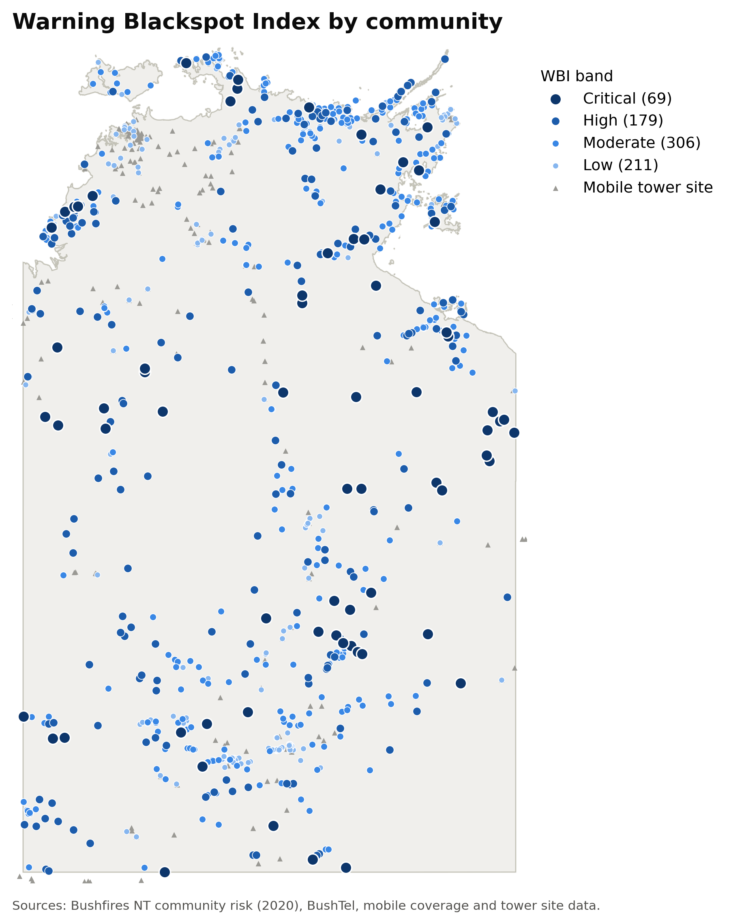
Figure 1. Warning Blackspot Index by community, grouped into bands. Grey triangles are mobile tower sites. Sources: Northern Territory Government (2020, 2024); ACCC (2026a).
3.2 High fire risk with no network to carry a warning
Fifty-three communities are rated High fire risk, lie outside predicted coverage and have no carrier tower within 35 km. For these communities a mobile warning cannot arrive over any network: the median distance to the nearest tower is 52 km and the furthest is 117 km. Twenty of the 53 are in the Barkly region and 51 are family outstations.
3.3 Fire risk and reachability move together, but weakly
Communities with a higher risk rating tend to be harder to reach. Median unreachability rises from 0.29 for Low-risk communities to 0.60 for Moderate and 0.68 for High (Figure 2). The relationship is consistent but weak (Spearman rank correlation 0.18): many High-risk communities are well connected and many Low-risk communities are not. Fire risk alone is therefore a poor guide to where warnings will fail, which is why the index combines the two.
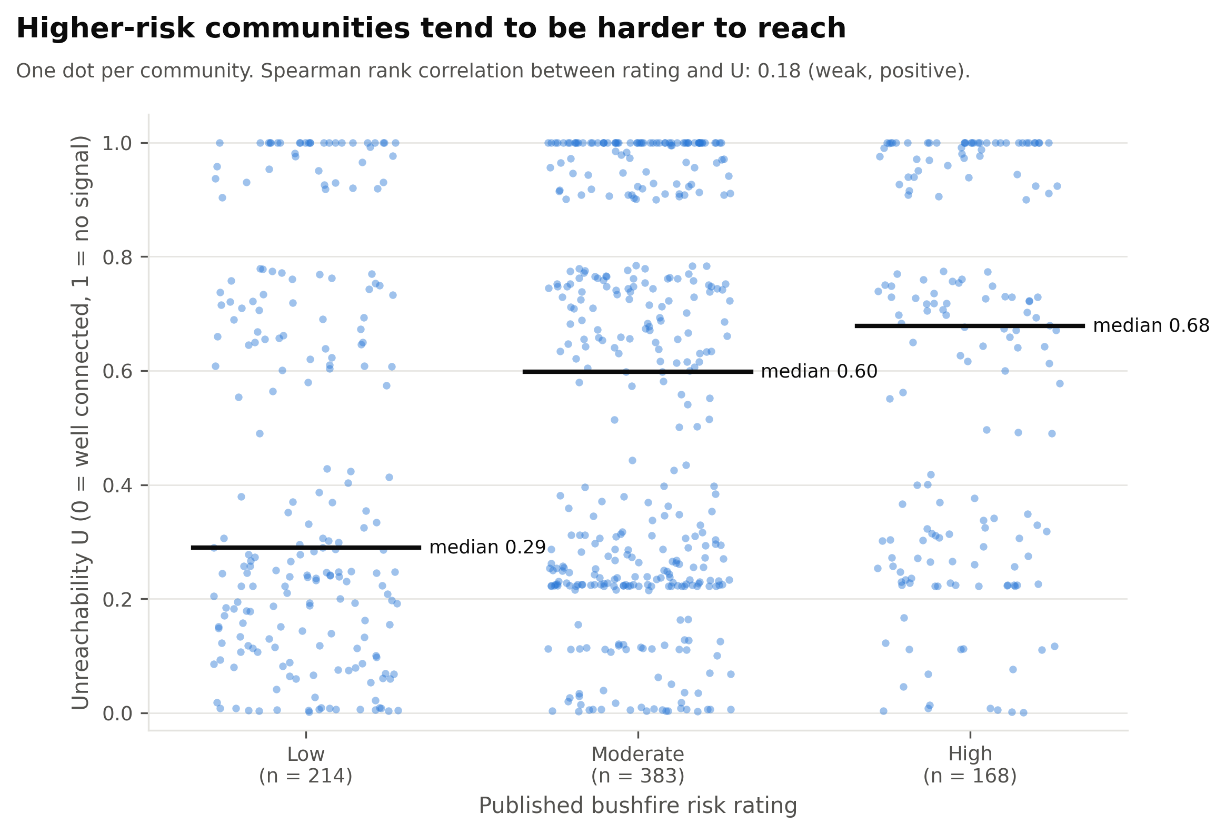
Figure 2. Unreachability (U) by published bushfire risk rating. Each dot is one community; black lines mark the median.
3.4 The least reachable are the least counted
Neither the risk dataset nor BushTel records a population for a third of communities (251 of 765, 33%). The gap is not random: it rises to 64% in the Critical band (44 of 69) and to 81% among the 53 High-risk communities with no reachable network (43 of 53). The ten of those 53 with a recorded population account for 282 people; how many live in the other 43 is unknown. Gaps in coverage and gaps in counting fall on the same places, which is itself a finding about how connectivity is represented.
3.5 Preparedness
Recorded preparedness falls steeply with rated risk (Figure 3). No High-risk community records an approved fire plan (0 of 168), against 7% of Moderate and 21% of Low-risk communities. Firebreaks and fuel reduction follow the same pattern more sharply: every Low-risk community records both, compared with 16% of High-risk communities. A gradient this clean suggests these measures form part of how the rating is assigned, so we treat it as context rather than as independent evidence of neglect (Section 2.2).
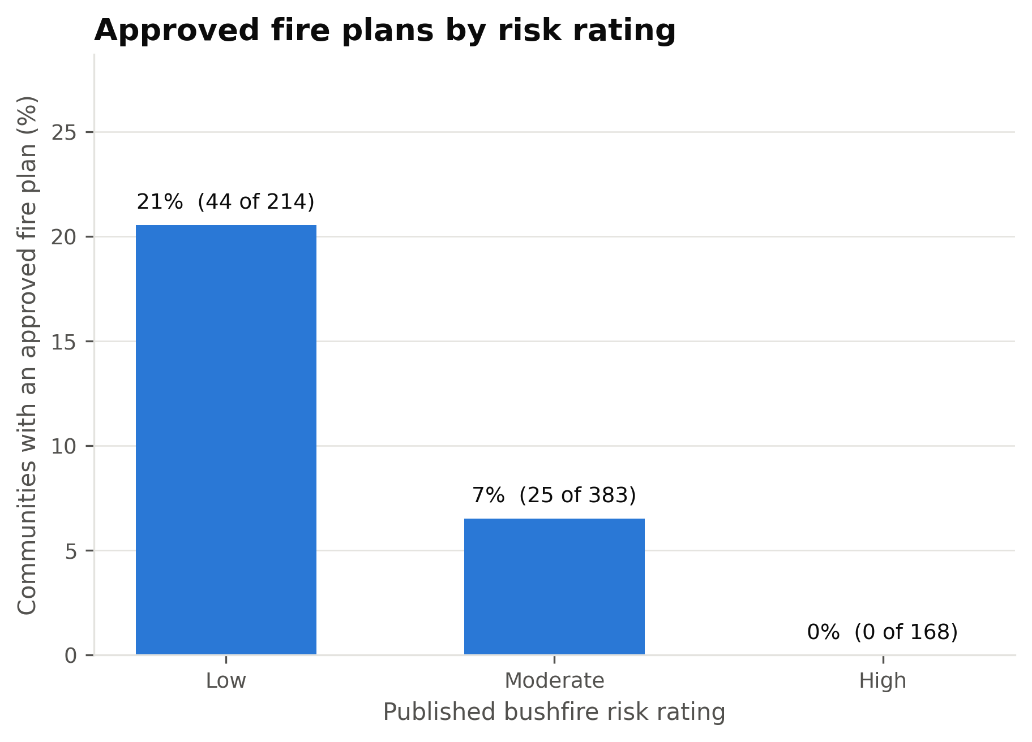
Figure 3. Share of communities with an approved fire plan, by published risk rating.
3.6 Robustness
The Critical list does not hinge on any single parameter: under ten of the eleven alternatives in Section 2.4, between 81% and 99% of Critical communities remain Critical. The highest-scoring communities with a recorded population are listed in Appendix D for planning use.
3.7 Prototypes
Two prototypes put the findings to work. The Blackspot Ops dashboard (connectivity-dashboard1) shows the index for all 765 communities on a map and in a searchable directory. It reads the scores written by wbi_index.py, so it displays the same numbers as this report, and it runs from bundled files without a server.
The offline-first reporting app (Warning_Blackspot_App_Source_Code) shows how people in low-connectivity communities could report local hazards. Its home screen shows the current fire danger level, nearby hazards and a local map. A trusted community representative can report dry or tall grass, smoke, fire or floodwater by choosing an icon, taking a photo, adding notes and recording the GPS location, in English or Murrinh Patha with audio guidance. Without signal, the report is saved on the device in browser LocalStorage with the status "queued"; when a connection returns, the app syncs it to a Cloudflare D1 database and marks it "synced". A native Android and iOS version (mobile/, React Native with Expo) follows the same offline-first flow: it stores reports on the device, detects when connectivity returns, and uploads them to a small reports API that the dashboard displays on its Field Reports page. Both are proofs of concept, not official warning services: a production version would need user testing, secure accounts, privacy protection and agreement with communities and agencies.

4. Discussion
Data and privacy. All datasets used in the index are open government data (Appendix A) and describe communities rather than individuals. The smallest unit of analysis is a community, and population figures are published community totals. We did not combine sources to identify households or people.
Indigenous data and community authority. Most of the 765 communities are Aboriginal communities and outstations. Publishing a ranked list of them raises questions of who controls data about these communities and how it is used. We follow the CARE principles for Indigenous data governance: collective benefit, authority to control, responsibility and ethics (Carroll et al., 2020). The index describes a gap in service delivery, not a shortcoming of any community: a high score means a warning may not reach people, and responsibility for closing that gap lies with agencies and carriers. We therefore present bands rather than a public ranking, avoid language that could be read as blaming communities, and keep the named list in an appendix for planning use. The index does not establish what a community wants done about the gap, so any action on Recommendations 1 and 2 should follow consultation with the relevant land councils and regional councils.
Counting and visibility. That population is missing for 43 of the 53 communities hardest to warn is a community impact in itself. Communities that are invisible in the data are easy to leave out of planning, and our imputed values keep them in the index but cannot say how many people are at risk.
Risk of misuse and false confidence. A ranking can be misused, for example to deprioritise communities that score low. The index depends on ratings current as at 30 June 2020, on predicted rather than measured coverage, and on estimated population for a third of communities. A low score is therefore not evidence of safety. The index is meant to help decide where to look first, not to replace local knowledge or on-site assessment.
Prototype applications. The offline apps are not an official emergency warning service, and a production version would need to say so clearly. Several privacy issues would need to be resolved before real use:
- Reports contain GPS location, photos and notes. Photos may capture people or private property, so a real version would need consent guidance and a way to remove reports.
- Queued reports are held in browser LocalStorage or on-device app storage, neither of which is encrypted, so a shared or lost device could expose them.
- Reports sync to a cloud database (Cloudflare D1) or to the reports API. A real deployment would need secure accounts, access controls, a retention policy and a decision on where data is held.
- Only trusted community representatives should be able to submit reports, and the community should decide who that is. The prototype holds no real personal data.
Language and accessibility. The prototype offers English and Murrinh Patha, but the Northern Territory has many Aboriginal languages. Translations and audio guidance should be reviewed by fluent speakers before use, and further languages added according to community priorities rather than our assumptions.
Use of AI tools. AI tools used in this project, the tasks they supported and how their output was checked are declared in Appendix B.

5. Recommendations
1. Sequence connectivity investment by reachability, not risk alone (NT Government and carriers). The 53 High-risk communities with no network within 35 km, and the 69 in the Critical band, are where a warning is least likely to arrive. Where a full network solution is not economic, lower-cost options warrant assessment, including satellite messaging devices held at community level and emergency-only roaming.
2. Adopt offline-first fallbacks for warnings and reporting (NTFES and regional councils). Our prototype shows that hazard reports can be recorded without signal and synced later. A printed community fire card carrying the risk rating, nearest brigade and muster point would be a low-cost complement that needs no signal or device, and could be generated for every community from the same data.
3. Count the uncounted (NT Government and BushTel custodians). Population is missing for 251 communities, including 43 of the 53 hardest to warn. Recording it would let emergency planners size a response and make any index of this kind more reliable.
4. Publish currency and method notes with the risk ratings (Bushfires NT). The ratings date from 30 June 2020 and the method is not published, so users cannot tell whether preparedness measures feed into the rating. A review date and a short method note would let downstream users judge how much weight the rating still carries.
Recommendations 1 and 2 assume consultation with the relevant land councils and regional councils before any deployment. The index identifies where a service gap exists; it does not establish what a community wants done about it.

References
Australian Competition and Consumer Commission. (2026a). ACCC Mobile Infrastructure Report - data release [Data set]. data.gov.au. https://data.gov.au/data/dataset/accc-mobile-infrastructure-report-data-release
Australian Competition and Consumer Commission. (2026b, September 22). Mobile infrastructure report 2026. https://www.accc.gov.au/by-industry/telecommunications-and-internet/mobile-services-regulation/mobile-infrastructure-report/mobile-infrastructure-report-2026
Carroll, S. R., Garba, I., Figueroa-Rodríguez, O. L., Holbrook, J., Lovett, R., Materechera, S., Parsons, M., Raseroka, K., Rodriguez-Lonebear, D., Rowe, R., Sara, R., Walker, J. D., Anderson, J., & Hudson, M. (2020). The CARE principles for Indigenous data governance. Data Science Journal, 19(1), 43. https://doi.org/10.5334/dsj-2020-043
Geoscape Australia. (n.d.). Geoscape administrative boundaries [Data set]. data.gov.au. https://data.gov.au/data/dataset/geoscape-administrative-boundaries
Gillies, S., van der Wel, C., Van den Bossche, J., Taves, M. W., Arnott, J., Ward, B. C., & others. (2025). Shapely (Version 2.1) [Computer software]. https://github.com/shapely/shapely
Hunter, J. D. (2007). Matplotlib: A 2D graphics environment. Computing in Science & Engineering, 9(3), 90-95. https://doi.org/10.1109/MCSE.2007.55
Northern Territory Fire and Emergency Services. (2025). NT fire history [Data set]. NTG Open Data Portal. https://data.nt.gov.au/dataset/nt-fire-history
Northern Territory Government. (2020). Bushfire risk for remote communities in the Northern Territory [Data set]. NTG Open Data Portal. https://data.nt.gov.au/dataset/bushfire-risk-for-remote-communities-in-the-northern-territory
Northern Territory Government. (2024). BushTel community profiles (Com_BushTel_Profile_CMC_2024) [Data set]. https://spatial.infrastructure.gov.au/server/rest/services/Hosted/Com_BushTel_Profile_CMC_2024/FeatureServer/0
QGIS Development Team. (2026). QGIS geographic information system [Computer software]. Open Source Geospatial Foundation. https://qgis.org
The pandas development team. (2024). pandas-dev/pandas: Pandas [Computer software]. Zenodo. https://doi.org/10.5281/zenodo.3509134

Appendix A: Data provenance
Dataset | Custodian | Downloaded | Licence | Known limitation
Bushfire Risk for Remote Communities in the NT | Bushfires NT (NT Government) | September 2026 | CC BY 4.0 | Ratings current as at 30/06/2020; population missing for 290 of 765
NT Fire History | NT Fire and Emergency Services | September 2026 | CC BY 4.0 | Extract covers approx. Jan to Aug 2025 only
BushTel community profiles (CMC 2024) | NT Government | September 2026 | Not stated on service | Population missing for many outstations; matched by name (762) or location (1)
ACCC Mobile Infrastructure Report data release: 2026 site register and coverage map | ACCC | September 2026 | CC BY 2.5 AU | Reported by carriers, predicted not measured; polygons and sites disagree for 28 communities
Geoscape administrative boundaries (NT) | Geoscape Australia | September 2026 | See data.gov.au | Used for map outline only

Appendix B: AI usage declaration
Tool | Used for | How output was checked
Gemini, ChatGPT, Claude, Deepseek | Planning; drafting and reviewing the Python index pipeline, dashboard data loading and figures; drafting report text and checking slide figures against the code output | The team re-ran the pipeline, compared every number in the report and slides, and reviewed and edited all text

Appendix C: Source code and repository
Repository: https://github.com/HendrickDang/nt-warning-blackspot-index. The index is computed by Bushfire_analysis/wbi_index.py, the descriptive figures by Bushfire_analysis/bushfire_analysis.py, and the slide figures by Bushfire_analysis/slide_figures.py. To reproduce: pip install -r Bushfire_analysis/requirements.txt, then python Bushfire_analysis/wbi_index.py. Outputs are written to Bushfire_analysis/outputs/, and the dashboard in connectivity-dashboard1/ reads the same results. The offline reporting web app is in Warning_Blackspot_App_Source_Code/, the native mobile app in mobile/, and the field reports API in connectivity-dashboard1/server/. Full instructions are in README.md.

Appendix D: Highest-scoring communities
Provided for planning use by agencies. Scores describe gaps in service, not the capability of communities, and should not be published as a ranking without consultation with the communities and land councils concerned. Communities with no recorded population share an estimated value, so they are counted in the note above the chart rather than ranked, and are listed in Bushfire_analysis/outputs/wbi_scores.csv.
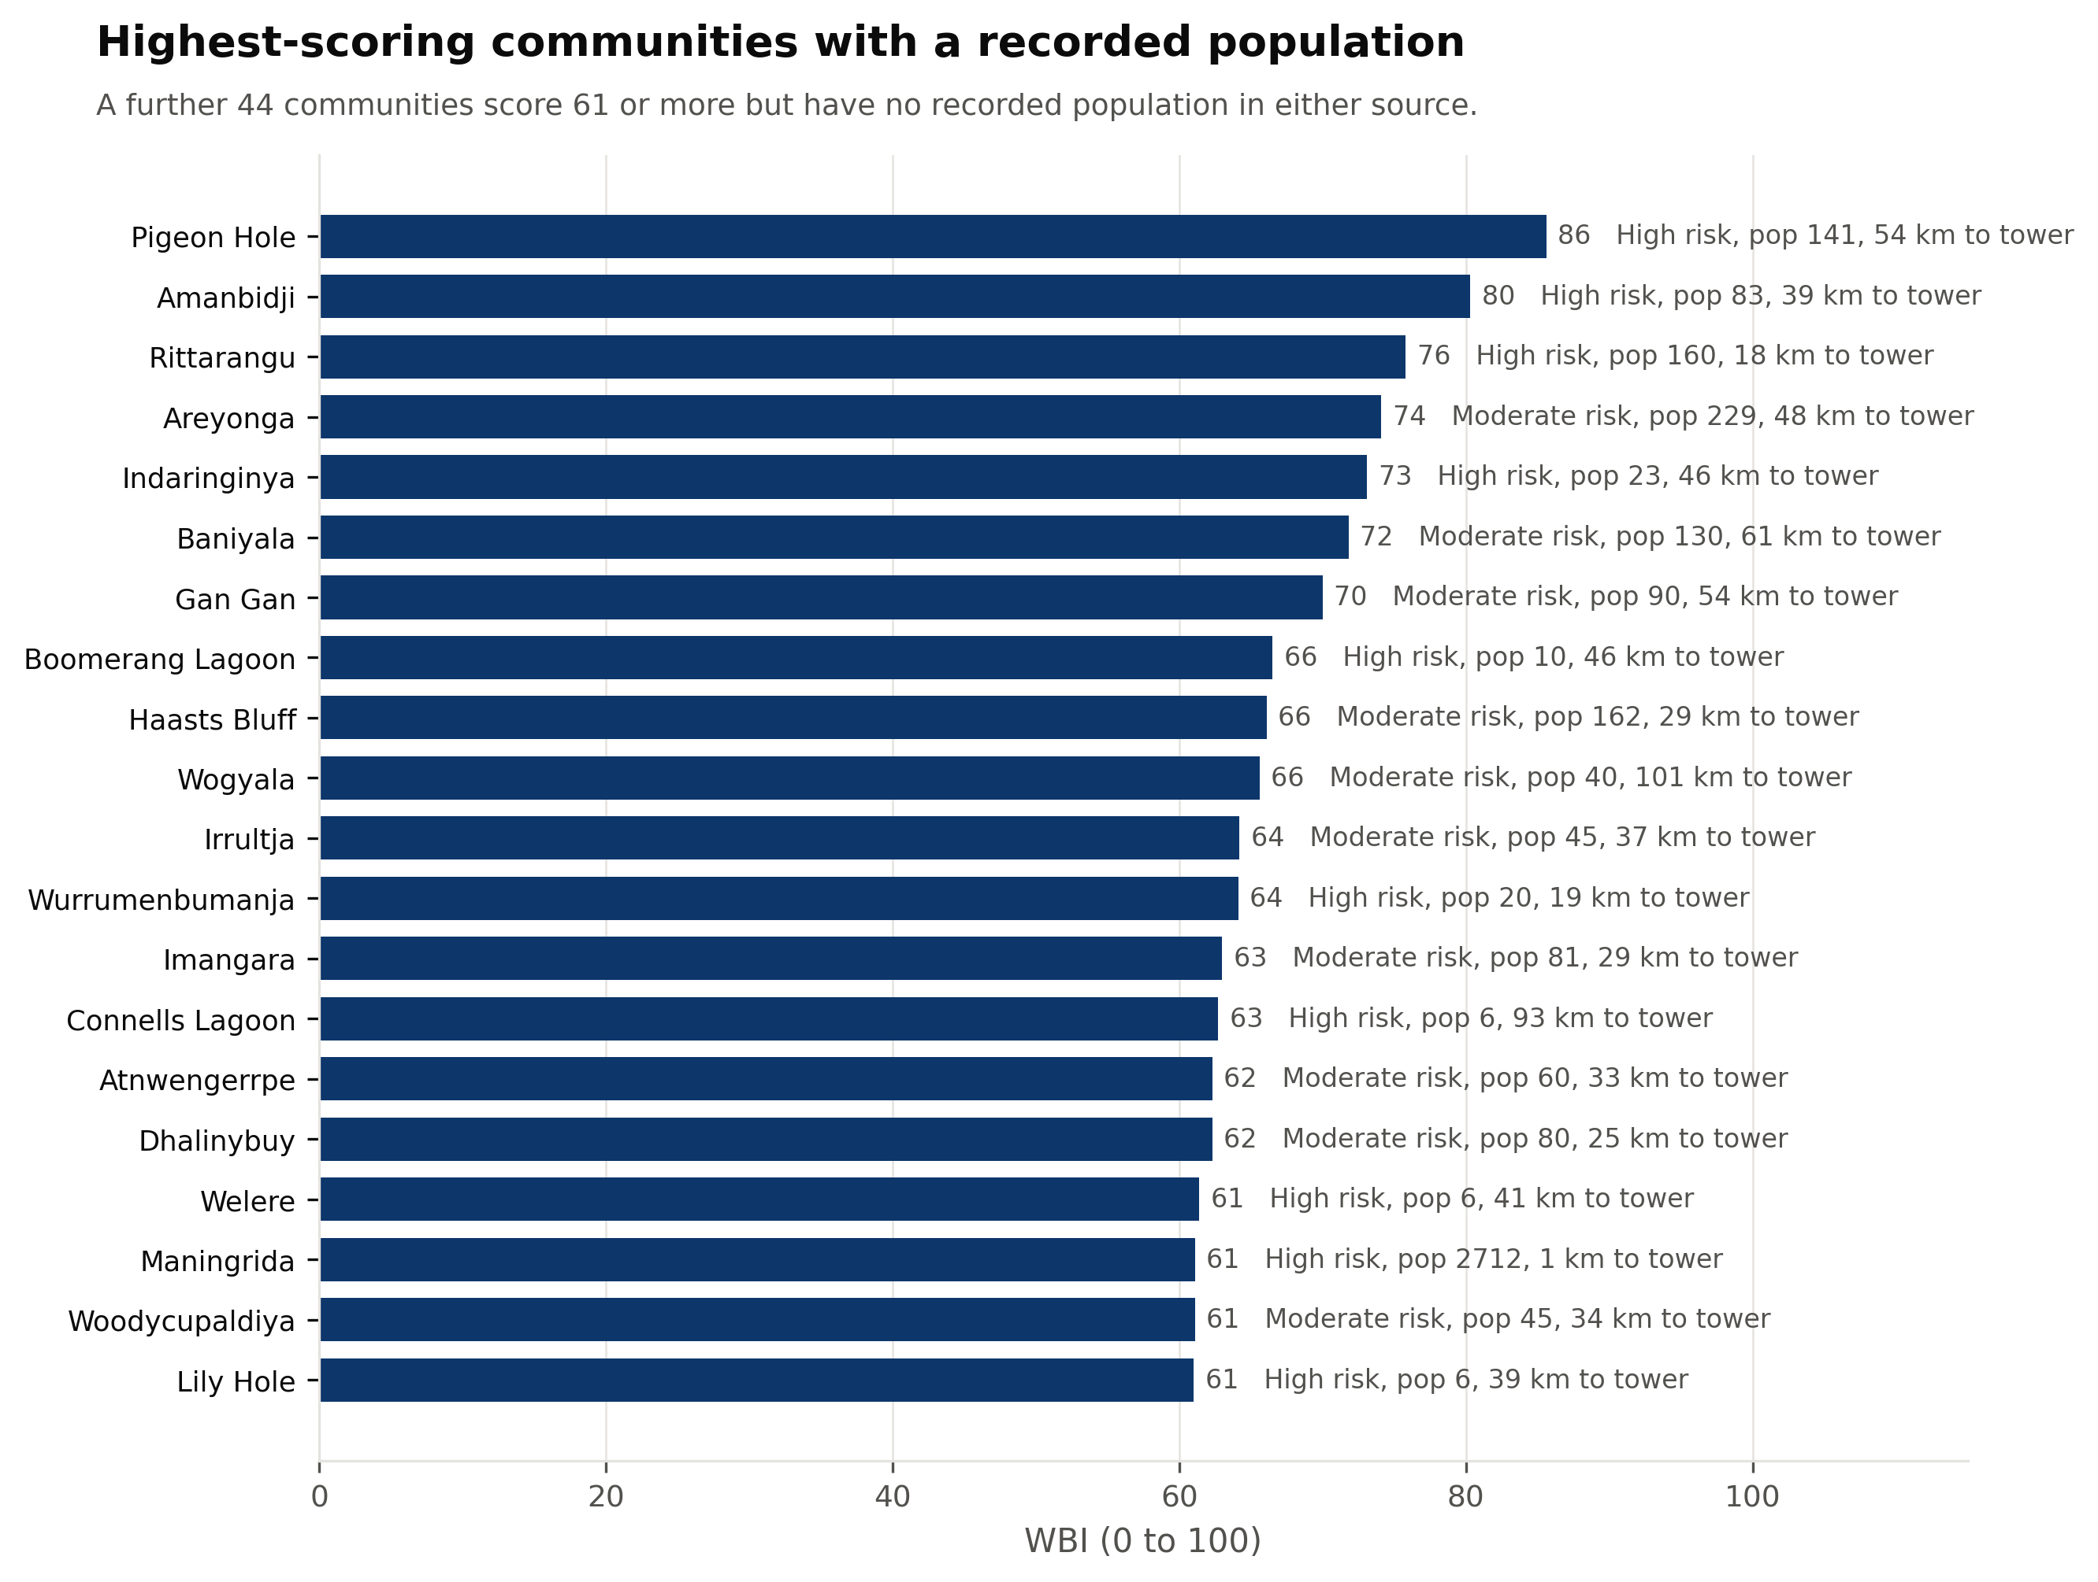
Figure D1. Highest-scoring communities with a recorded population.

